

**SPA1051B**

May 1 2025

|  |
| --- |
| **DC to Breadboard Power Adapter PCB** |

**FEATURES**

* **Selectable 5 V Regulated Output**
* **Accepts Inputs Up To 12 V**
* **Up To 100 mA Output Current**
* **Internal Short-Circuit Protection**
* **Integrated Thermal Shutdown Protection**
* **Integrated Decoupling Capacitors**
* **Low Resistance (Under 10 mΩ)**
* **Life Span of 10 000 Switches**
* **Compact 12.5x30 mm Size**
* **Manually Manufacturable**

**DESCRIPTION**

The SPA1051B is a compact power adapter designed to connect a DC barrel jack to the power rails of a standard breadboard.

It provides selectable output between the input voltage of up to 12V and regulated 5V using a physical slide switch. The compact 12.5x30 mm form allows it to fit in non‑intrusively. It is ideal for powering circuits during prototyping on breadboards.

The 5 V regulator integrates thermal shutdown protection, allowing it to be left on for extended periods of time at high power demands without risk of damage. In addition, the device has been designed with thermals in mind, featuring a high thermal mass, resulting in smaller temperature rises.

|  |  |
| --- | --- |
|  |  |

See device information for dimensions

**Device Overview**

* hanxia HX MSS12C02-BB2.0 Slide Switch

<https://www.lcsc.com/datasheet/lcsc_datasheet_2410121534_hanxia-HX-MSS12C02-BB2-0_C25168817.pdf>

* Slkor (SLKORMICRO Elec.) LM78L05D 5V Linear Regulator

<https://www.lcsc.com/datasheet/lcsc_datasheet_2401051154_Slkor-SLKORMICRO-Elec--LM78L05D_C5330393.pdf>

When choosing capacitors and resistors, ensure power ratings are adequate for their functions on the device. The 12 V limit is due to the slide switch, the linear regulator is capable up to 30 V.

**Electrical Characteristics**

|  |  |  |  |  |
| --- | --- | --- | --- | --- |
|  | **Min** | **Typ.** | **Max** | **Unit** |
| Vin Input Voltage (Vin selected) | 0 | 9 | 12 | V |
| Vin Input Voltage (5 V selected) | 7 | 9 | 12 | V |
| Vout Output Voltage (when 5 V selected) | 4.8 | 5 | 5.2 | V |
| VD Dropout Voltage (when 5 V selected) |  | 1.7 |  | V |
| Iout | 10 | 50 | 100 | mA |
| Resistance (25°C) | 10 | 20 | 50 | mΩ |
| Operating Temperature | -40 | 35 | 150 (Tj) | °C |

**Schematics & Technical Diagrams**



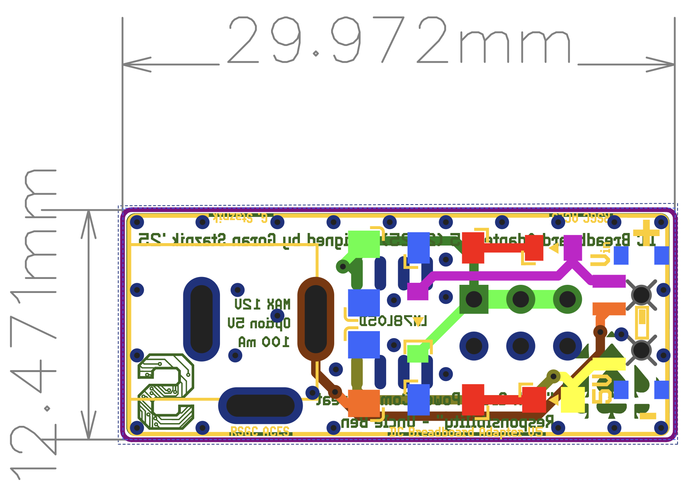

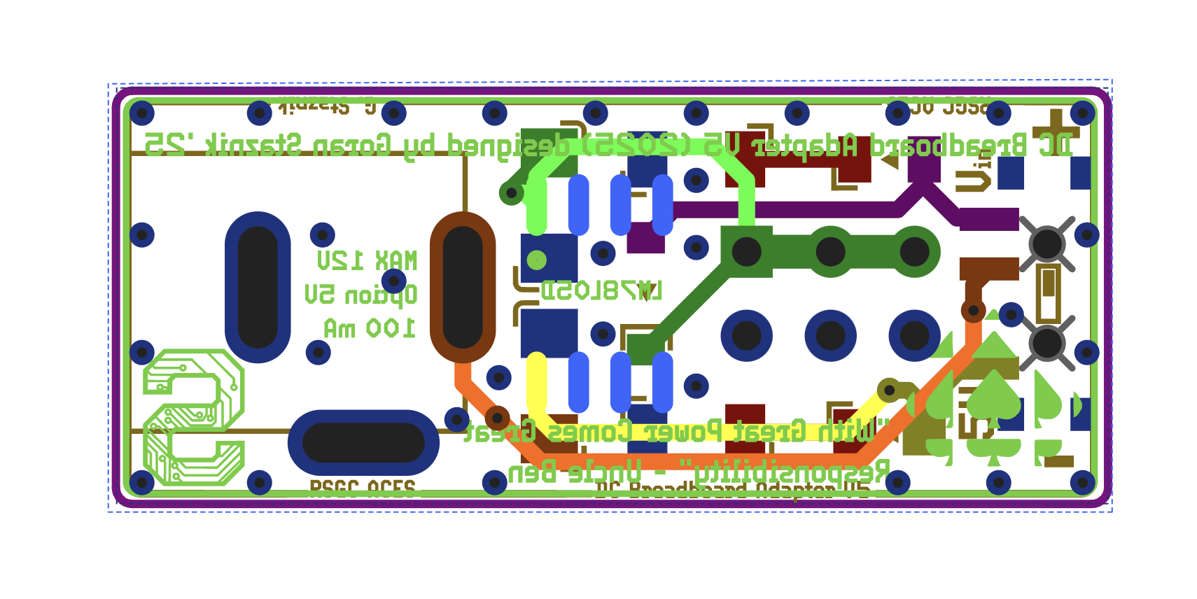

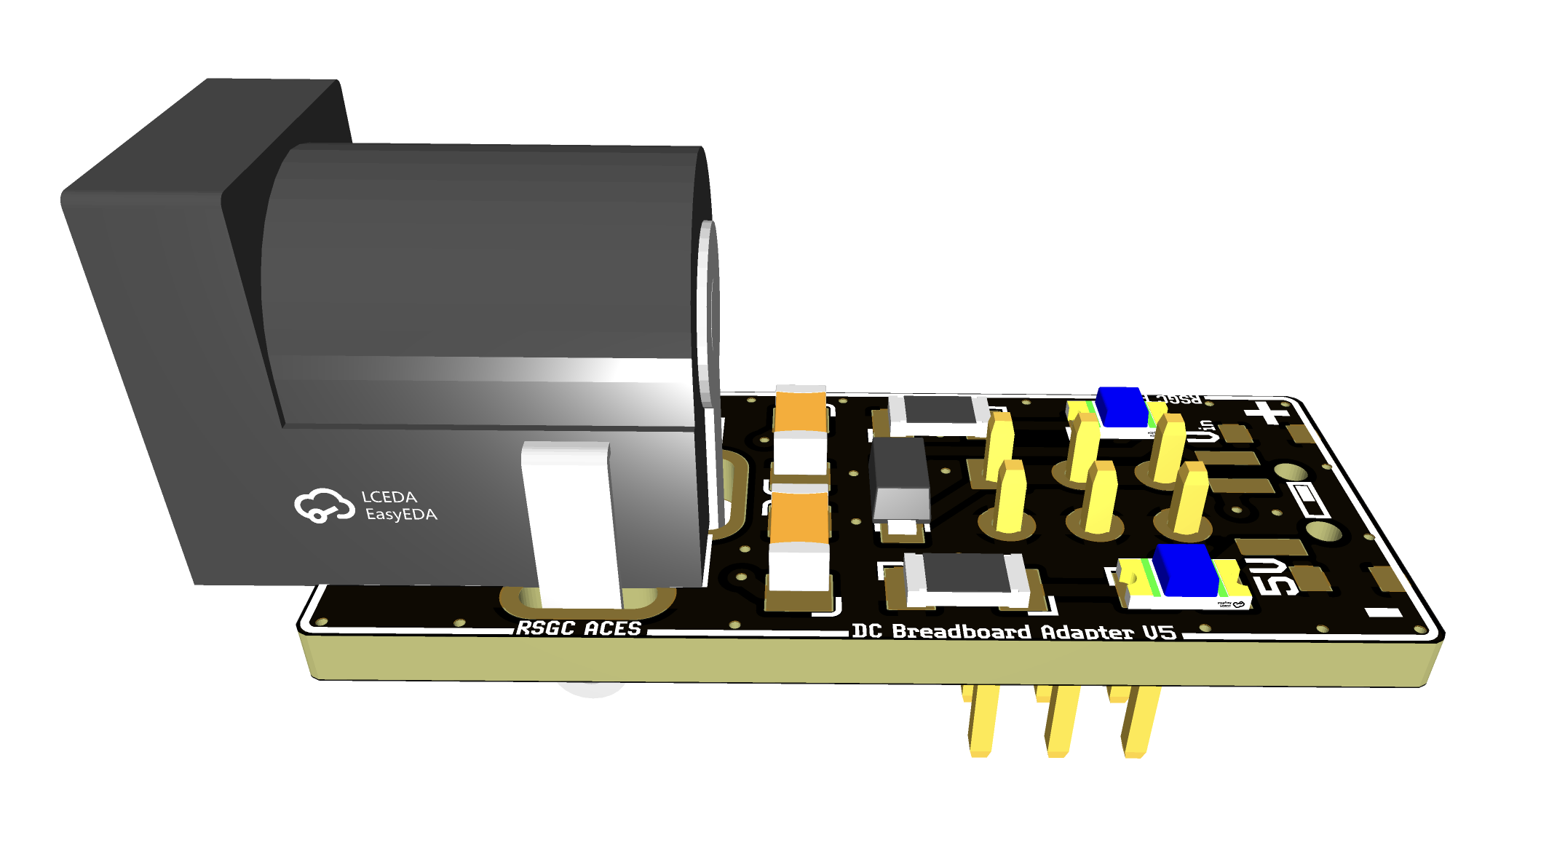

Note that a 3D model for the slide switch was not found, and does not appear in the rendering.

**Ordering Information**

The SPA1051B was designed with the express purpose of ease and low cost of manufacture. All parts were ensured to be available on LCSC. Additionally, it was elected to use parts of 1206 package for easy of manual assembly.

Below are the specifications that are required to produce the SPA1051B PCB:

|  |  |  |
| --- | --- | --- |
|  | **Spec.** | **Unit** |
| Minimum Trace clearance | 0.6 | mm |
| Minimum Trace Width | 20 | mil |
| Minimum Via Drill Size | 0.3 | mm |
| Via Hole to Hole Spacing | 0.6 | mm |
| Trace/Via to Copper Pour Clearance | 0.6 | mm |
| Minimum Character Width | 6 | mil |

Here are the specifications when producing or ordering the PCB:

|  |  |  |
| --- | --- | --- |
|  | **Spec.** | **Unit** |
| PCB Layers | 2 |  |
| Board Material | FR-4 |  |
| Board Thickness* | 1.6 | mm |
| Board Dimensions | 12.5x30 | mm |
| Colour | -- |  |
| Surface Finish** | -- |  |
| Outer Copper Weight | 1 | oz |
| Via Coverings | -- |  |

*Other thicknesses are acceptable, though it is recommended to keep the board thin for better grounding with the ground pours.

**Surface finish can be determined by the user, however, ENIG is recommended for applications requiring stocking the un-manufactured PCB for long periods of time. Tough HASL is acceptable in most cases.

When manufacturing the PCB, ensure that all components are correctly placed, and the direction of the diode, LEDs and linear voltage regulator IC are correct. Also ensure that the chosen parts match the specifications.

**Important Notice**

Staznik Systems provides this open-source hardware design “as-is” and makes no warranties regarding its reliability, functionality, or fitness for a particular purpose. Users are responsible for verifying the suitability of this design for their specific applications and for incorporating appropriate safety and performance safeguards.

This design is released under an open-source license for educational, hobbyist, and experimental use. While reasonable care has been taken to ensure the accuracy and utility of the design, Staznik Systems assumes no liability for any damage or loss resulting from the use of this design or any derivative work.

Modifications, redistribution, and use in commercial or non-commercial applications are permitted, provided that proper credit is given and any derivative works are clearly marked as such. The name “Staznik Systems” and any associated logos or marks may not be used to promote derivative works without prior written permission.

Staznik Systems does not authorize the use of this design in life-critical or safety-critical systems without an explicit and separate agreement.

© Staznik Systems. This project is open-source. All contributions and derivatives must comply with the accompanying license.